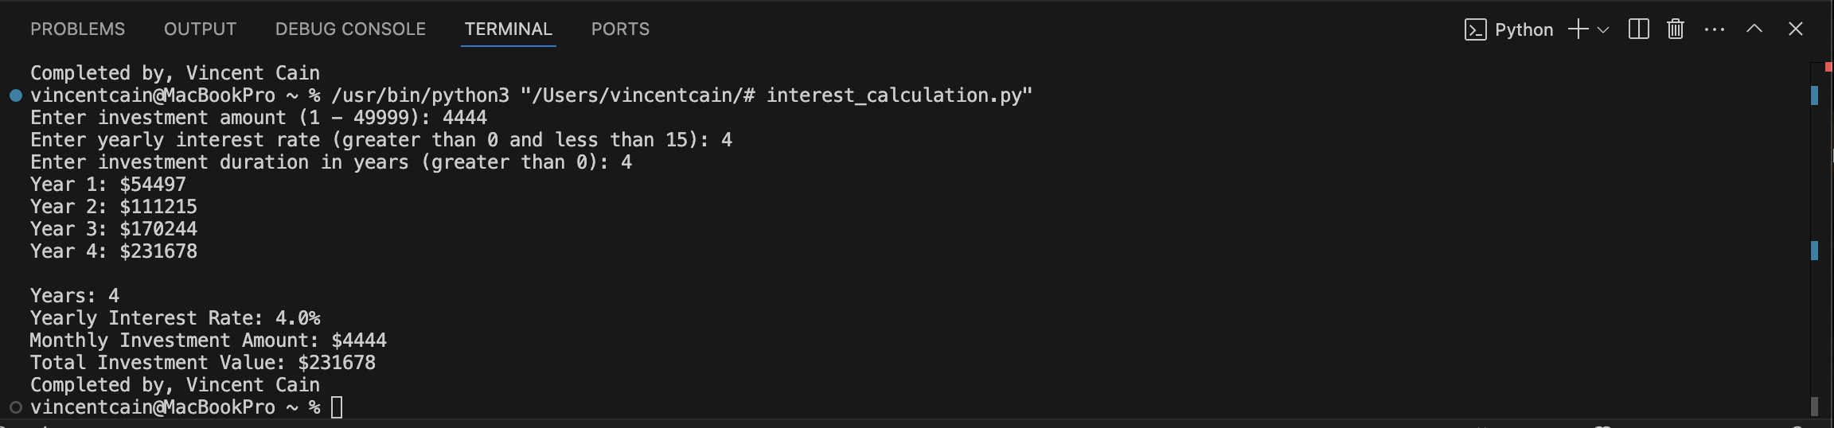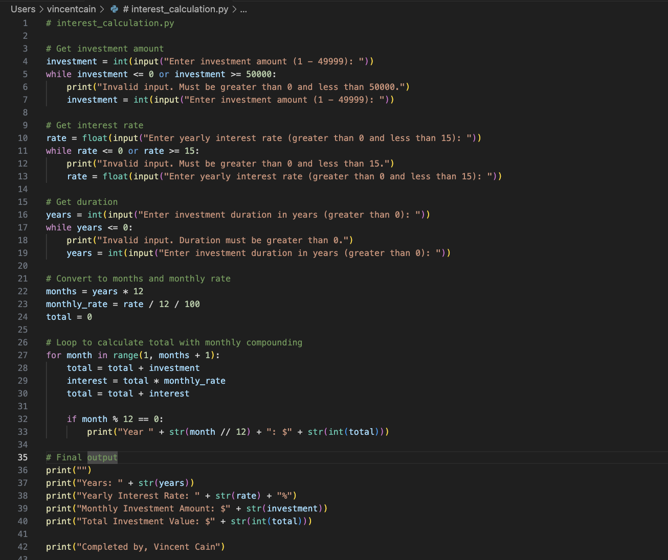# interest_calculation.py

# Get investment amount

investment = int(input("Enter investment amount (1 - 49999): "))

while investment <= 0 or investment >= 50000:

print("Invalid input. Must be greater than 0 and less than 50000.")

investment = int(input("Enter investment amount (1 - 49999): "))

# Get interest rate

rate = float(input("Enter yearly interest rate (greater than 0 and less than 15): "))

while rate <= 0 or rate >= 15:

print("Invalid input. Must be greater than 0 and less than 15.")

rate = float(input("Enter yearly interest rate (greater than 0 and less than 15): "))

# Get duration

years = int(input("Enter investment duration in years (greater than 0): "))

while years <= 0:

print("Invalid input. Duration must be greater than 0.")

years = int(input("Enter investment duration in years (greater than 0): "))

# Convert to months and monthly rate

months = years * 12

monthly_rate = rate / 12 / 100

total = 0

# Loop to calculate total with monthly compounding

for month in range(1, months + 1):

total = total + investment

interest = total * monthly_rate

total = total + interest

if month % 12 == 0:

print("Year "+ str(month // 12) + ": $" + str(int(total) ))

# Final output

print ("")

print("Years: " + str(years) )

print("Yearly Interest Rate: " + str(rate) + "g")

print("Monthly Investment Amount: $" + str(investment))

print("Total Investment Value: $" + str(int(total) ))

print ("Completed by, Vincent Cain")